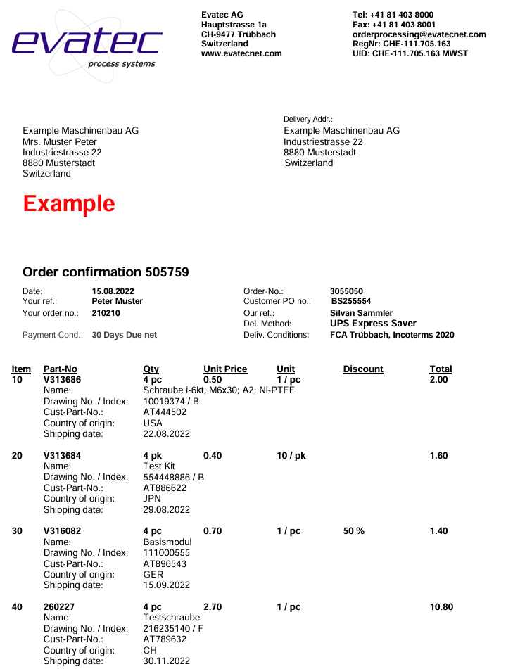
22.8.2026
22.8.2026
22.8.2026
Delivery Date:
Delivery Date:
Delivery Date:
Delivery Date:
22.8.2026

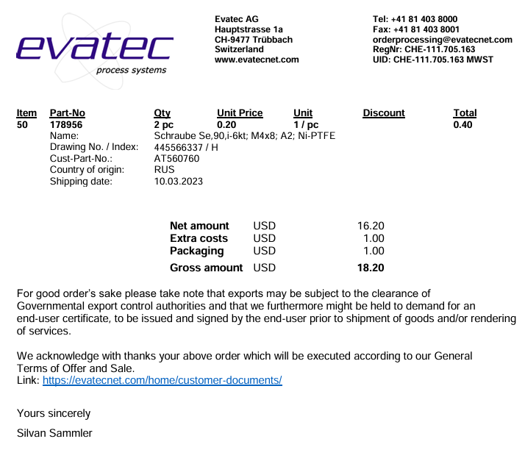
22.8.2026
Delivery Date:

